August 2016
Dear Friends and Family,
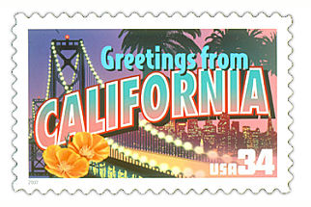
This year my 5th grade class is taking on a project called “Postcards across America” to help us learn about the 50 states. Since we cannot travel to all of the states in only one year, our goal is to receive a postcard from each of the 50 states! Here is how the project works:
- Please mail us a picture postcard from your state or a state you are visiting (anytime between September 2016 and May 2017).
On the back of the post card please write one sentence to tell the class about yourself and what you are doing in that state. Then, please write one sentence that tells a historical or interesting fact about that state.
*If you travel to more than one state, please send us postcards throughout the year. We would love to hear from you multiple times!

- Please address the postcard like this:

Kenwood Elementary School
Attn: Mrs. Forster’s 5th Grade
P.O. Box 220
Kenwood, CA 95452-0220

- Once we receive the postcard, we will learn facts about the state, locate it on our map, and determine the region to which the state belongs!
Thank you for helping us to reach our goal!
Sincerely,

